- Gibson, Charles (Charlie)

PATIENT: CHARLES GIBSON (CHARLIE)
DOB: OCTOBER 12, 1942
AGE: 74
SEX: MALE
INSURANCE: BC/BS of SENECA

- Reason for Visit
- HPI
- Allergies
Presented to the Emergency Room complaining of a fluttering in his chest for the past couple of weeks on and off. The time of onset of the dizziness and syncope was approximately 30 minutes ago.
Has history of hypertension for which he refuses to take the medication prescribed for him. Patient states "I feel fine without it." He has the medication but has not yet opened the prescription bottle.
Has been diagnosed with Diabetes Mellitus Type II for which he takes Metaforim at 1000 mg/day.
Keeps up with his doctor's visits which are scheduled every four months.
Smokes a half of a pack of cigarettes every day. Cut down from one pack per day over the past couple of years as his doctor told him.
Enjoys all kinds of food including fried food, fast food and "soft drinks".
He has no acute distress.
No Known Allergies
- Initial Visit
HR_ 82 NSR
BP- 130/80
RR- 18 Reg
Temp -98.6
Sat 96% on 2 L/min oxygen

- Orders
Admit s/p stroke.
Vital signs every four hours with O2 saturation.
Diet: Nectar Thick
Swallow evaluation and call with results.
PT/OT consult
Telemetry bed
Metformin 1000mg po every 12 hours
Enteric Coated aspirin 81 mg po every day
Persantine 75mg po every day
Losartan 75mg po every day
Amiodarone 200 mg po every day
- METFORMIN
- ENTERIC COATED ASPIRIN
- PERSANTINE
- LOSARTAN
- AMIODARONE
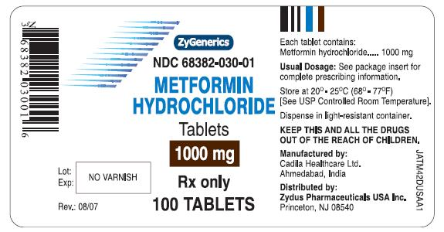

Receives 1000 mg daily
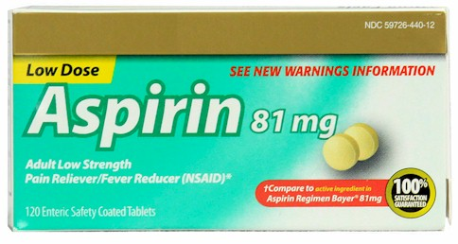
81 mg po every day
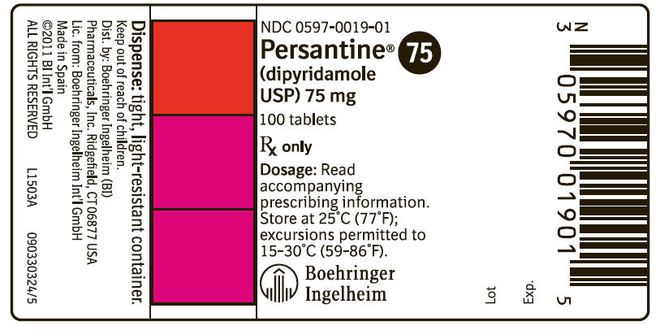
75 mg po every day
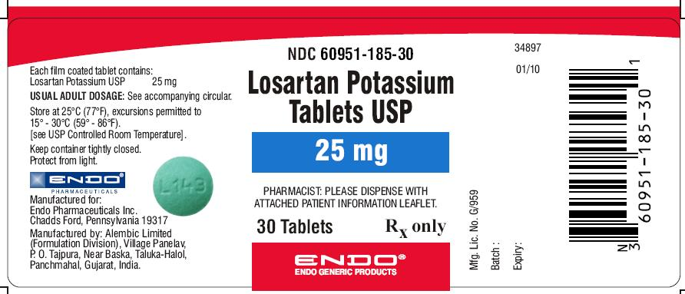
75 mg po every day

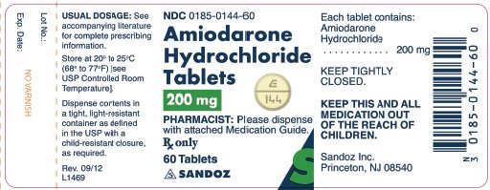
200 mg po every day

Notes:
Post Stroke MRI showed evidence of recent ischemic event with no worsening ischemia and reperfusion to compromised area of cortex.
Patient Gibson suffers some speech difficulties which looks to be motor in origin. Is able to identify words when shown a picture of several everyday items.
Tolerating nectar thick diet without incident. Will progress to soft -diet if swallow evaluation results are consistent with this.
He is staying motivated but expresses remorse about not “being able to do what he did before”.
He remains in sinus rhythm, HR 80s since cardioversion with Amiodarone one week ago..
His BP stays in the 130s systolic and he assured us that he would be “good about taking his new medicines”.
Will continue to follow.
Discharge goal- two weeks from today with once weekly RN visits and outpatient PT/OT three times a week.

Conversation with Mrs. Gibson:
how is charles doing today?
[16:36] Lucinda Gibson: I think he does better every day. He really likes the staff here.
how is the physical therapy going
[16:36] Lucinda Gibson: Some days are better than others. He knows he can’t do what he did before the stroke and I think it affects him.
is he looking forward to going home
[16:36] Lucinda Gibson: Yes! The doctor said that he may be able to go home in about two weeks.

